18th Sunday in Ordinary Time
First Reading: Isaiah 55:1-3
Thus says the Lord:
All you who are thirsty, come to the water!
You who have no money, come, receive grain and eat;
Come, without paying and without cost, drink wine and milk!
Why spend your money for what is not bread; your wages for what fails to satisfy?
Heed me, and you shall eat well, you shall delight in rich fare. Come to me and listen, that you may have life. I will renew with you the everlasting covenant, the benefits assured to David.

Responsorial: Psalm 144:8-9, 15-18
Response: The hand of the Lord feeds us: he answers all our needs.
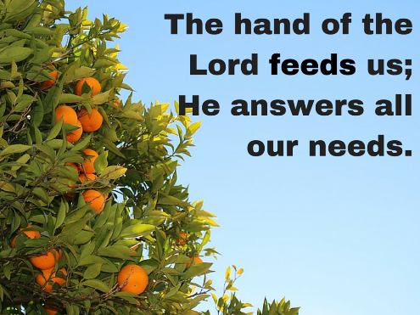
The Lord is kind and full of compassion,
slow to anger, abounding in love.
How good is the Lord to all,
compassionate to all his creatures. Resp:
The eyes of all creatures look to you
and you give them their food in due time.
You open wide your hand,
grant the desires of all who live. Resp:
The Lord is just in all his ways
and loving in all his deeds.
He is close to all who call him,
call on him from their hearts. Resp:

Second Reading: Romans 8:35-39
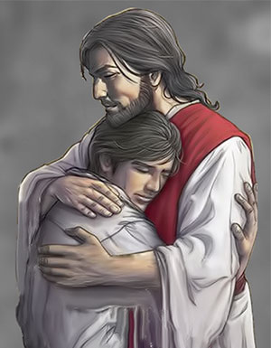
Brothers and sisters:
What will separate us from the love of Christ?
Will anguish, or distress, or persecution, or famine,
or nakedness, or peril, or the sword?
No, in all these things we conquer overwhelmingly
through him who loved us.
For I am convinced that neither death, nor life,
nor angels, nor principalities,
nor present things, nor future things,
nor powers, nor height, nor depth,
nor any other creature will be able to separate us
from the love of God in Christ Jesus our Lord.

Gospel Acclamation:
Alleluia ! Alleluia !
No one lives on bread alone,
But on every word that comes from the mouth of God.
Alleluia !

Gospel: Matthew 14:13-21
Five Loaves and Two Fish
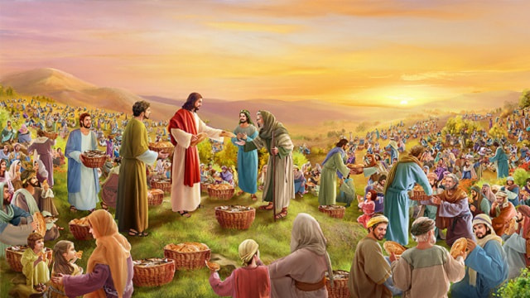

When Jesus heard of the death of John the Baptist, he withdrew in a boat to a deserted place by himself. The crowds heard of this and followed him on foot from their towns. When he disembarked and saw the vast crowd, his heart was moved with pity for them, and he cured their sick.
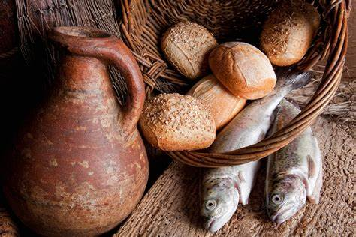
When it was evening, the disciples approached him and said, “This is a deserted place and it is already late; dismiss the crowds so that they can go to the villages and buy food for themselves. ” Jesus said to them, “There is no need for them to go away; give them some food yourselves. ” But they said to him, “Five loaves and two fish are all we have here. ” Then he said, “Bring them here to me, ” and he ordered the crowds to sit down on the grass.
Taking the five loaves and the two fish, and looking up to heaven, he said the blessing, broke the loaves, and gave them to the disciples, who in turn gave them to the crowds. They all ate and were satisfied, and they picked up the fragments left over — twelve wicker baskets full. Those who ate were about five thousand men, not counting women and children.

REFLECTIONS:
The crowds in today’s Gospel had nothing to eat, but our Lord knew they had another hunger apart from that of the stomach. They followed Jesus, listening to every word he spoke, and in none of the stories does it say that they were bothered about food for the body. In today’s episode, it is the apostles who expressed this concern, on behalf of the people. In another place it says that Jesus “looked at the crowd, and felt sorry for them, because they had been with him for several days, and had nothing to eat.” Yet the twin-hungers in today’s world are for meaning as well as for food.
Jesus sets the apostles a seemingly impossible challenge. When they point out the lack of food he tells them to feed the people themselves. This, of course, cannot be done, and they tell him so. He then taught them, and us, a basic lesson: “Whatever you have is enough. Just let me have it, and I will do the rest.” At Cana, all they had was water, and it was all he needed; He would do the rest. In another version of this story, where one of the apostles says “We only have a few loaves and some fish, but what is that among so many?” The temptation was to put the loaves and fish back in the bag.
There is power in the actions of Jesus as he says a prayer and begins distributing the bread. Before he called Lazarus forth from the tomb, he raised his eyes to heaven, and said “I thank you, Father, that you have heard me.” It was his constant contact with the Father that inspired his actions. At his baptism in the Jordan he had heard the Father’s voice saying “This is my beloved Son, in whom I am well pleased.” He lived constantly with the Father’s approval, even when everyone else rejected him. What a lesson this is for all of us! In commissioning his apostles, later on, he would tell them to feed the hungry. Because he came “to do and to teach,” that is why he fed the hungry before sending his disciples to do the same.
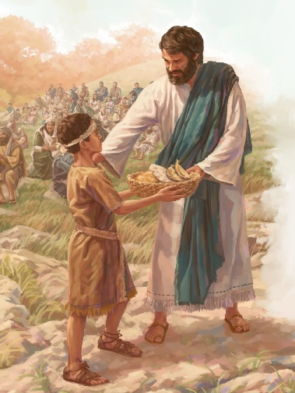
It is a scandal that so large a part of today’s world is made up of hungry people. Most of us have more than we need of money, clothes, food, etc. We may not have as much as we want, but we have more than we need. There is a struggle here, and there is a tension from which we cannot escape. “Whatever you do for the least of these, I will take as being done for me.” The decisions to walk in the Christian Way removes many of my options and choices. Christianity is much more than just saying prayers. It is also a call to action. It is a call to do as Jesus would do. I cannot read today’s Gospel and remain indifferent or detached. While reflecting on the focus of today’s Gospel, a deep emotional impression circulates in my mind and heart telling me that there are so many people in our parish of St. Christopher’s and St. Augustine’s who are multiplying “Five Loaves and Two Fish” in following the footsteps of Jesus by helping, supporting and giving food etc… for those in need during this time of Covid-19 pandemic and crisis in our parish. It is really a Christian beauty and a Christian way of living.
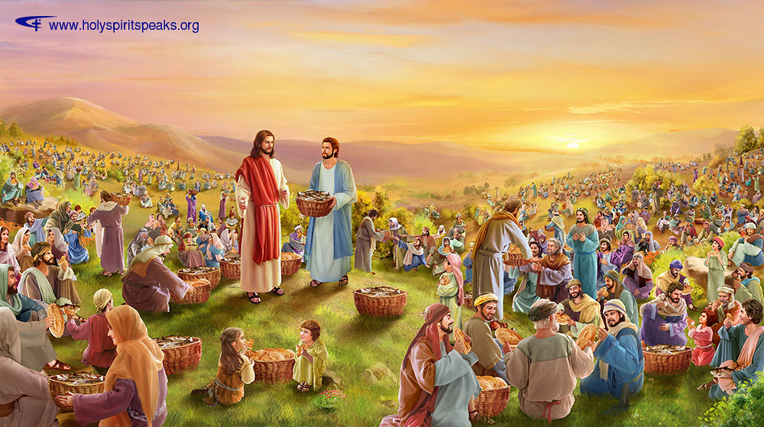
“It is in giving that we receive.” When we give, we discover that we are not at a loss. It is an extraordinary paradox, but it is literally me. I will never know this until I try it. How do you consider yourself in the whole area of responsibility for the welfare of others? We are all familiar with the Saint Vincent de Paul Society and other Catholic Charity Agencies…, and we may admire what they do. But we must go beyond admiration and become willing to imitate, and follow their example. Christianity is about witnessing, and in the witnessing is the invitation to “go and do likewise.” The opposite to love is not hatred, but indifference. If God is love, and I am indifferent, then I must seriously examine where God is in my life. This is a fundamental and basic question that must be asked, and it must be answered.

